**BIOINFORMATICS ASSIGNMENT 1 (Day 1 - 5)**

1.Gene Name:FGFR3

2.Function of the Gene: This gene encodes a member of the fibroblast growth factor receptor (FGFR) family,

3.NCBI accession number: >NC_000004.12

4.Forward Primer: CAGGTCCTTGTGTGAGCCTA

5.Reverse primer: TGCATGCCTCCCTAGATGAG

6.Features of primers : [start](https://primer3.ut.ee/cgi-bin/primer3/primer3/primer3web_help.cgi#p3w_primer_start)  [len](https://primer3.ut.ee/cgi-bin/primer3/primer3/primer3web_help.cgi#p3w_primer_len)  [tm](https://primer3.ut.ee/cgi-bin/primer3/primer3/primer3web_help.cgi#p3w_primer_tm)  [gc%](https://primer3.ut.ee/cgi-bin/primer3/primer3/primer3web_help.cgi#p3w_primer_gc)  [any_th](https://primer3.ut.ee/cgi-bin/primer3/primer3/primer3web_help.cgi#p3w_primer_any)  [3'_th](https://primer3.ut.ee/cgi-bin/primer3/primer3/primer3web_help.cgi#p3w_primer_three) [hairpin](https://primer3.ut.ee/cgi-bin/primer3/primer3/primer3web_help.cgi#p3w_primer_hairpin) [seq](https://primer3.ut.ee/cgi-bin/primer3/primer3/primer3web_help.cgi#p3w_primer_seq)

LEFT PRIMER : 2633 20 59.02 55.00 0.00 0.00 0.00

RIGHT PRIMER : 2820 20 58.95 55.00 16.68 0.00 0.00

7.Amplicon length and sequence:

Amplicone length : 188

Amplicone Sequence : CAGGTCCT

>>>>>>>>

2641 TGTGTGAGCCTAGGAACCCCTTGTTACCCACCCCCCAGCTCCCCAGCCCTCAGGTCTCAC

>>>>>>>>>>>>

2701 TTGGGGCTAGATCTGGGGCTGTGGCACCCCTTGTTACAGCTGAGCTTGAGTGGGAGCCCA

2761 GGGGCTTGGGGTCTCCTGGAGGACGGGGATCTAAAGTCACCTCATCTAGGGAGGCATGCA

<<<<<<<<<<<<<<<<<<<<

**qPCR Data analysis (DAY 5)**

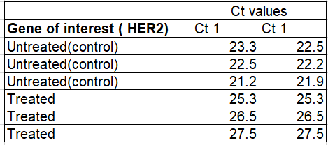

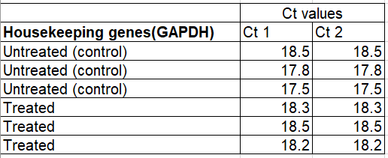The following data are results of qPCR from cancer cell lines. HER2 stands for human epidermal growth factor. It’s healthy in normal amounts, but too much may be a sign of a certain type of breast cancer. Calculate the 2 Delta Ct values for the following data and plot the values on a graph using graphpad prism.

|  |  |  |  |  |  |  |  |  |  |
| --- | --- | --- | --- | --- | --- | --- | --- | --- | --- |
|  | Housekeeping gene | | Gene of Interest | | **Average Ct value of HG** | **Average Ct value of GOI** | **ΔCt value** | **ΔΔCt value** | **Fold Change** |
| Ct1 | Ct2 | Ct1 | Ct2 |  |  |  |  |  |
| Control (untreated) | 18.5 | 18.5 | 23.5 | 22.5 | 18.5 | 23 | 4.5 | 0 | 1 |
| Treated 1 | 18.3 | 18.3 | 25.3 | 25.3 | 18.3 | 25.3 | 7 | 2.5 | 0.1767767 |
| Treated 2 | 18.5 | 18.5 | 26.5 | 26.5 | 18.5 | 26.5 | 8 | 3.5 | 0.0883883 |
| Treated 3 | 18.2 | 18.2 | 27.5 | 27.5 | 18.2 | 27.5 | 9.3 | 4.8 | 27.857618 |